CEMA CHIKV model
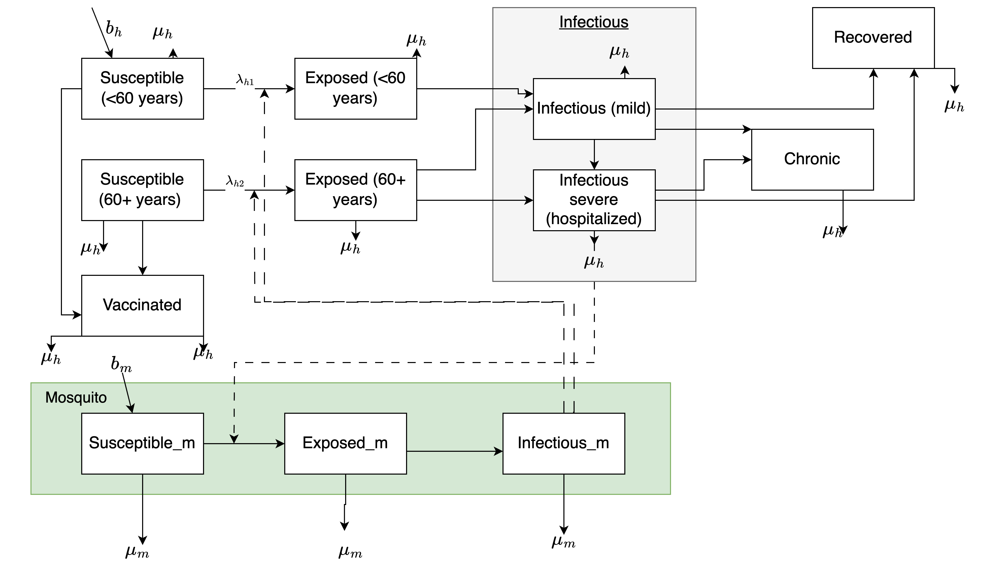
This compartmental model simulates chikungunya virus transmission dynamics in a population stratified by age groups (<60 years, 60+ years), with vector (mosquito) compartments. The model incorporates age-specific disease susceptibility and progression while accounting for the chronic nature of chikungunya infection. The compartments in the model are:

Human population compartments

- Age-specific compartments:
  - Susceptible individuals (<60 years, 60+ years): S₁, S₂
  - Exposed individuals (<60 years, 60+ years) who are infected but not yet infectious: E₁, E₂
- Age-independent compartments:
  - Individuals with mild infectious disease: I_{m}
  - Individuals with severe infectious disease: I_{s}
  - Chronic chikungunya: C
  - Recovered individuals with immunity: R
  - Vaccinated individuals: V

Vector population compartments
- Susceptible mosquitoes: S_{m}
- Exposed mosquitoes: E_{m}
- Infectious mosquitoes: I_{mosq}

Disease progression
- Susceptible individuals become exposed following infectious mosquito bites
- Exposed individuals progress to either mild or severe states (age-dependent probabilities)
- Infectious individuals either recover or progress to chronic disease
- Chronic individuals eventually recover (at a slower rate)
- Vaccination occurs directly from the susceptible population
- Infectious humans can infect susceptible mosquitoes.
- Infectious mosquitoes can infect suscetible humans.
- Human and mosquito populations are linked through transmission

Model assumptions
- Disease susceptibility varies by age group, with different contact rates and vaccination rates
- Once infected, individuals from both age groups contribute to the same infectious pools
- Older adults (60+) have higher probability of severe disease
- A proportion of infected individuals develop chronic symptoms
- Chronic individuals cannot transmit the virus
- Recovered individuals maintain lifelong immunity
- There is random mixing within the population
- Individuals do not transition between age groups during the simulation period
- No migration in or out of the population
- Mosquito population is maintained by equal birth ($b_{m}$) and death ($μ_{m}$) rates
- Mosquito life cycle parameters are constant (no seasonal variation)
- Mosquitoes become infectious immediately after the extrinsic incubation period
- Transmission rate depends on the proportion of infectious individuals
- Mild and severe infectious individuals have equal transmission potential
- Mosquitoes bite at a constant rate (no populaton density for now)
- Mosquitoes have equal contact with all human age groups

